May Magic!
JOIN THE COSTUME SOCIETY OF ONTARIO: Wheels on the Bus!
We’re taking a trip through Fashion History. Sunday, May 15, 2016.The CSO is bussing to Guelph and Cambridge for a Special Day outing to visit, view and enjoy two special exhibitions and locations in celebration of our 45th Anniversary! The Guelph Museum is hosting an display of fashions by Lucile, Lady Duff Gordon, from around the continent! Tied to the Titanic and the inspiration for the Downton Abbey outfit craze, these are rarely seen gowns and dresses. The CSO gets an exclusive look and lecture!
After the grand tour, hop back on the bus for a short trip to the Old Post Office at Hespeler, the New Home of the Fashion History Museum and CSO friends and family, Jonathan Walford and Kenn Norman, to enjoy the newest exhibits on Canada’s fashion contributions. Many years in the making, this is a ‘must see’ place to be! Plus the opportunity to enjoy fine local cuisine and the great communities just beyond !
ONLY 33 SPACES! Book Early! To Sign Up, or for more information, Contact:
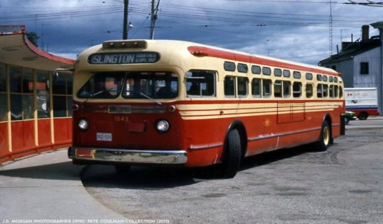
Diane Reid-- dhreid65@gmail.com 416 483 0907
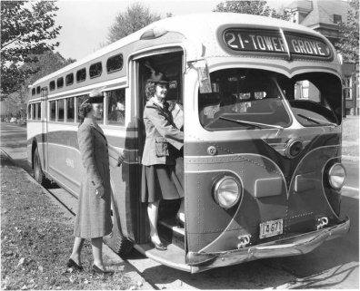
The bus leaves York Mills Subway Station at 9:00 a.m.
And for those in the west end of Hog Town, The Big Smoke, The 6 [ that’s Toronto for those not up on pop culture ], the bus will leave at 9:30 a.m. from the Islington Subway Station.
This will be a full day of fun, education, good company and insights all for the fabulously low price of just: S 65.00 per person. Join us today for a blast from the past!
Contact Diane at : dhreid65@gmail.com to book space and to confirm which pick up point you’ll be waiting! Cash/cheque or money order to CSO P.O. Box 981 Station “F” Toronto, M4Y 2N9 or check out our Website and Facebook for Paypal details. Watch for special e-mail notice! Time and space is limited for this extraordinary excursion! [ Singing on the bus is optional ]

